Cashout your investment in ISLA token

**Step 1:** On [Uniswap](https://app.uniswap.org/#/swap?inputCurrency=0x697ef32b4a3f5a4c39de1cb7563f24ca7bfc5947), swap your ISLA token (stored in your Metamask wallet) for ETH.

**IV-2-a-Insula Token (ISLA):**

*Instructions:*

1-*Copy paste* this link into your browser:<https://app.uniswap.org/#/swap?inputCurrency=0x697ef32b4a3f5a4c39de1cb7563f24ca7bfc5947>

If ISLA does not show up, click "import token and copy paste this address:

0x697ef32b4a3f5a4c39de1cb7563f24ca7bfc5947

2-When prompted*, import* “Uniswap default list”, *approve* ISLA & *swap* ISLA against ETH.

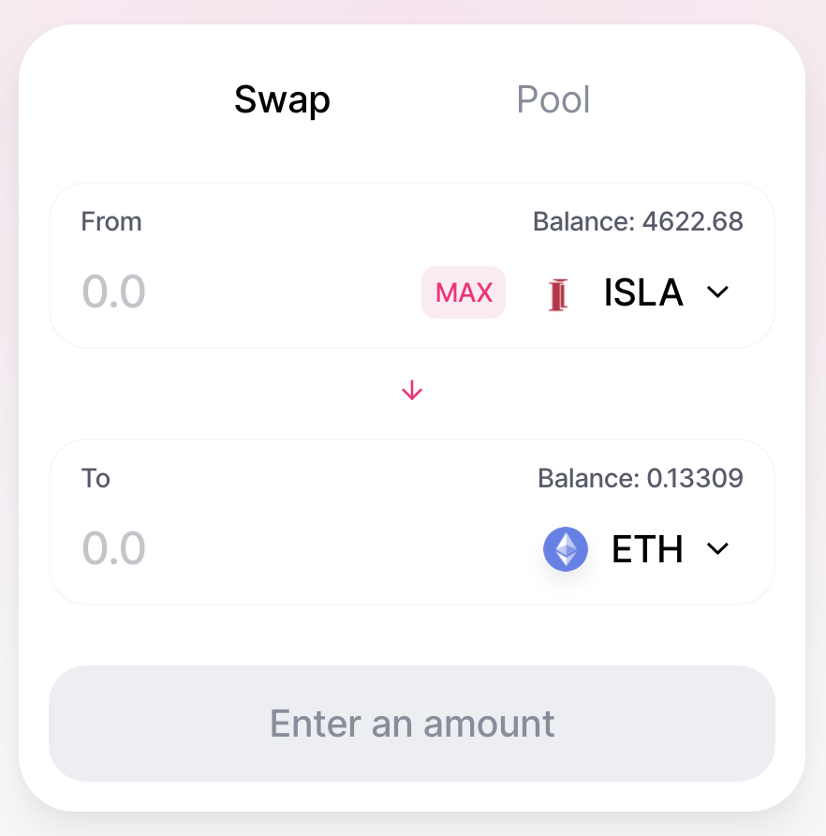

**Step2:** Once you managed to swap your ISLA to ETH, you’ll find your ETH on your Metamask wallet.

**Step3:** Now you can send your ETH from your Metamask to your Coinbase account. Make sure you know your Coinbase address. [See how here](https://metamask.zendesk.com/hc/en-us/articles/360028141672-How-to-send-deposit-tokens-to-your-MetaMask-Wallet)

**Step4:** After receiving your ETH on Coinbase, you can now sell your ETH and deposit the proceeds to your Bank account. [See how here](https://help.coinbase.com/en/coinbase/trading-and-funding/buying-selling-or-converting-crypto/how-do-i-sell-or-cash-out-my-digital-currency)